Dominic Drury

09/16/2024

CS-470

3-1 Assignment: Create a Static Website on S3

Bucket Name URL

<http://drury.lafs.web.s3-website-us-east-1.amazonaws.com/>

Static website hosting dialog that shows S3 configured as a server

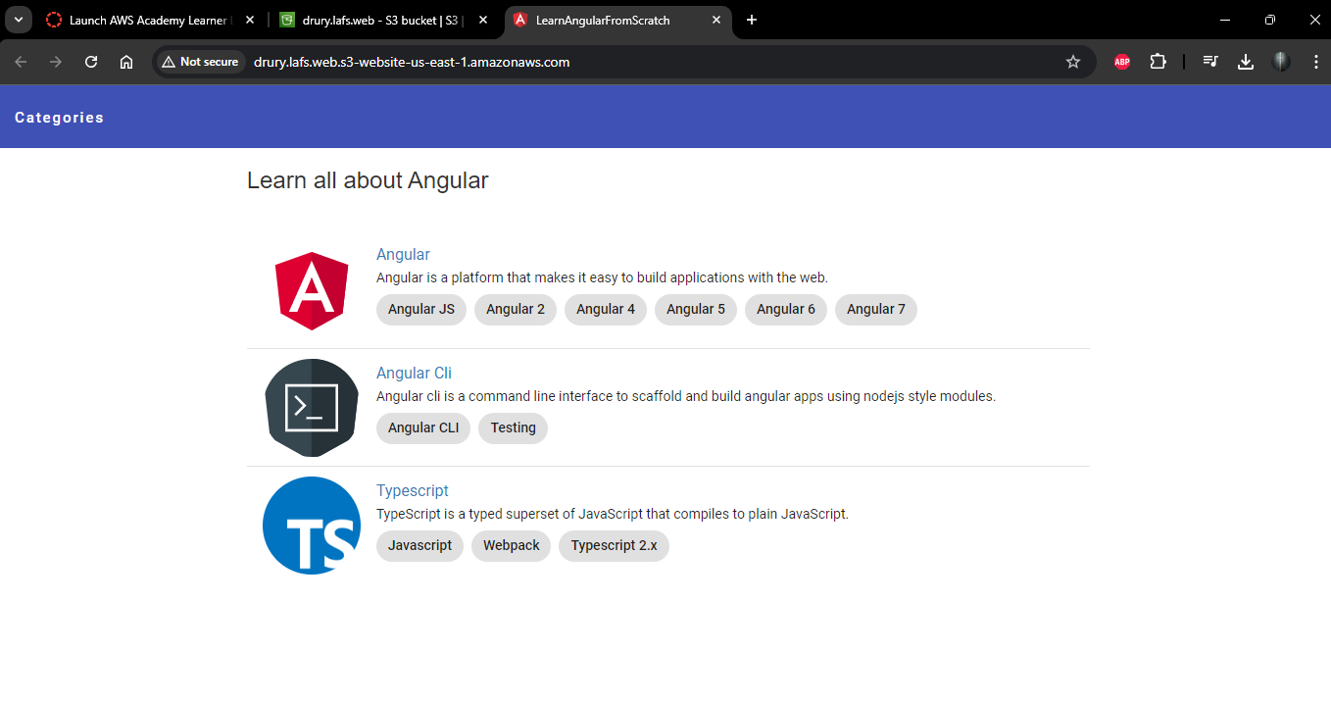

Settings showing the permissions of the bucket with public access allowed

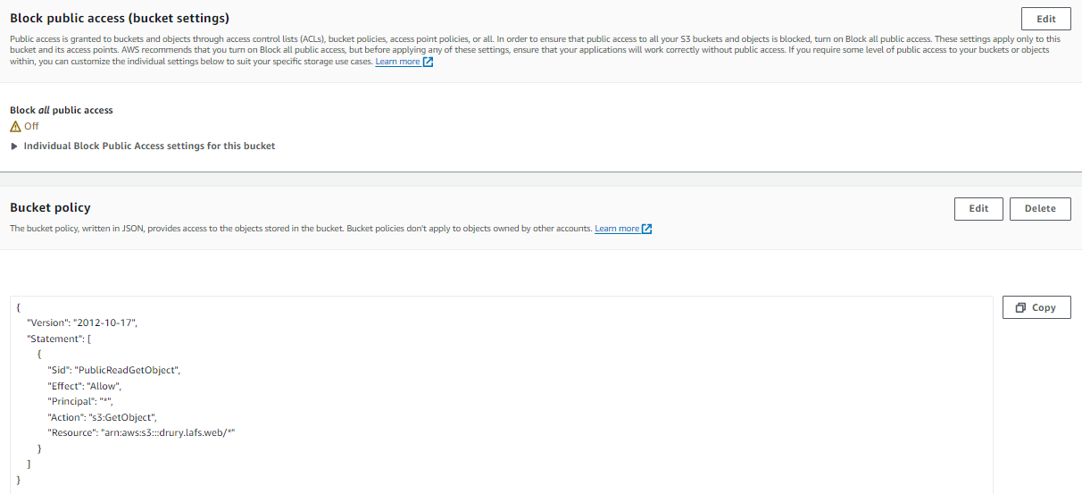

The S3 bucket showing Angular files

